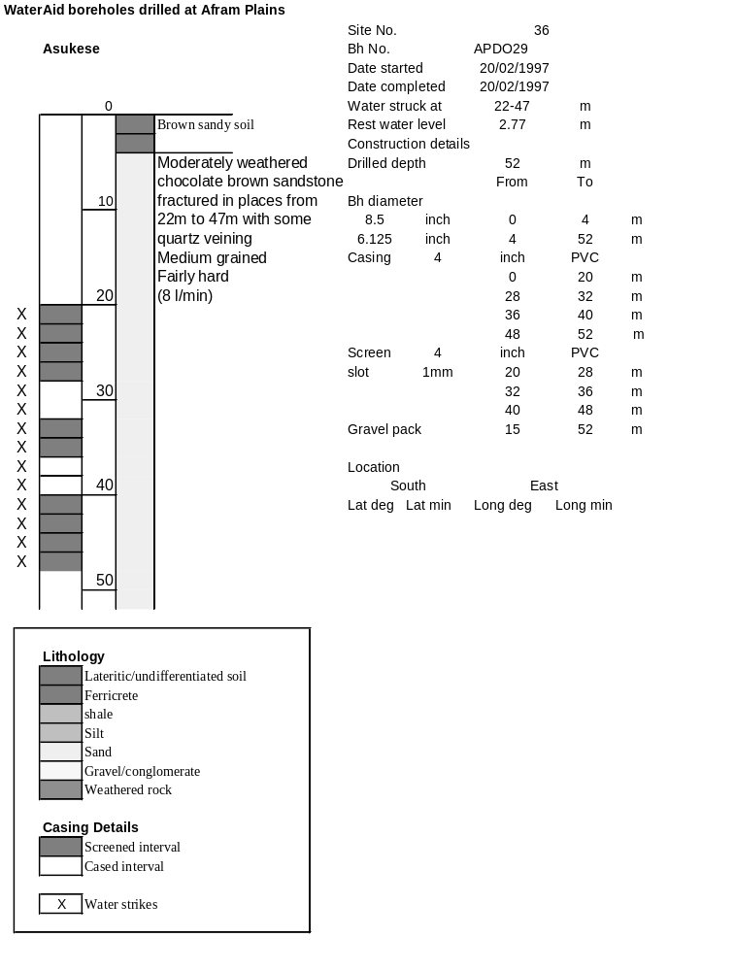

Ghana | Test pumping
Borehole No. |  | APDO 29
Hole No |  | 36
Village |  | Asukese
Date |  | 22/02/1997
Point above GL |  | 0.5 | m
Pump depth |  | 43 | m
SWL |  | 2.77 | m
Start Time |  | 00:00
Drawdown test |  |  |  |  | Recovery Test
time | pwl (m) | Q l/min | dd | sc(q/s) | Time | wl (m) | t/t' | resdd
0.00 | 2.77 | 7.00 | 0.00 |  | 0.00 | 17.98 |  | 15.21
1.00 | 7.78 | 7.00 | 5.01 | 1.40 | 1.00 | 17.30 | 181.00 | 14.53
2.00 | 7.66 | 7.00 | 4.89 | 1.43 | 2.00 | 16.60 | 91.00 | 13.83
3.00 | 7.85 | 7.00 | 5.08 | 1.38 | 3.00 | 15.91 | 61.00 | 13.14
4.00 | 8.11 | 7.00 | 5.34 | 1.31 | 4.00 | 15.27 | 46.00 | 12.50
5.00 | 8.38 | 7.00 | 5.61 | 1.25 | 5.00 | 14.67 | 37.00 | 11.90
6.00 | 8.62 | 7.00 | 5.85 | 1.20 | 6.00 | 14.09 | 31.00 | 11.32
7.00 | 8.75 | 7.00 | 5.98 | 1.17 | 7.00 | 13.50 | 26.71 | 10.73
8.00 | 8.84 | 7.00 | 6.07 | 1.15 | 8.00 | 12.87 | 23.50 | 10.10
9.00 | 9.00 | 7.00 | 6.23 | 1.12 | 9.00 | 12.19 | 21.00 | 9.42
10.00 | 9.15 | 7.00 | 6.38 | 1.10 | 10.00 | 11.63 | 19.00 | 8.86
11.00 | 9.30 | 7.00 | 6.53 | 1.07 | 12.00 | 10.53 | 16.00 | 7.76
12.00 | 9.43 | 7.00 | 6.66 | 1.05 | 14.00 | 9.55 | 13.86 | 6.78
13.00 | 9.56 | 7.00 | 6.79 | 1.03 | 16.00 | 8.84 | 12.25 | 6.07
14.00 | 9.66 | 7.00 | 6.89 | 1.02 | 18.00 | 8.12 | 11.00 | 5.35
15.00 | 9.77 | 7.00 | 7.00 | 1.00 | 20.00 | 7.52 | 10.00 | 4.75
16.00 | 9.91 | 7.00 | 7.14 | 0.98 | 22.00 | 7.04 | 9.18 | 4.27
17.00 | 10.05 | 7.00 | 7.28 | 0.96 | 24.00 | 6.65 | 8.50 | 3.88
18.00 | 10.19 | 7.00 | 7.42 | 0.94 | 26.00 | 6.34 | 7.92 | 3.57
19.00 | 10.32 | 7.00 | 7.55 | 0.93 | 28.00 | 6.10 | 7.43 | 3.33
20.00 | 10.45 | 7.00 | 7.68 | 0.91 | 30.00 | 5.90 | 7.00 | 3.13
22.00 | 10.68 | 7.00 | 7.91 | 0.88 | 35.00 | 5.54 | 6.14 | 2.77
24.00 | 10.89 | 7.00 | 8.12 | 0.86 | 40.00 | 5.30 | 5.50 | 2.53
26.00 | 11.10 | 7.00 | 8.33 | 0.84 | 45.00 | 5.12 | 5.00 | 2.35
28.00 | 11.32 | 7.00 | 8.55 | 0.82 | 50.00 | 4.98 | 4.60 | 2.21
30.00 | 11.51 | 7.00 | 8.74 | 0.80 | 60.00 | 4.77 | 4.00 | 2.00
35.00 | 11.96 | 7.00 | 9.19 | 0.76 | 70.00 | 4.55 | 3.57 | 1.78
40.00 | 12.37 | 7.00 | 9.60 | 0.73 | 80.00 | 4.40 | 3.25 | 1.63
45.00 | 12.82 | 7.00 | 10.05 | 0.70 | 90.00 | 4.30 | 3.00 | 1.53
50.00 | 13.22 | 7.00 | 10.45 | 0.67 | 100.00 | 4.20 | 2.80 | 1.43
55.00 | 13.56 | 7.00 | 10.79 | 0.65 | 110.00 | 4.12 | 2.64 | 1.35
60.00 | 13.91 | 7.00 | 11.14 | 0.63 | 120.00 | 4.06 | 2.50 | 1.29
70.00 | 14.46 | 7.00 | 11.69 | 0.60
80.00 | 14.94 | 7.00 | 12.17 | 0.58
90.00 | 15.36 | 7.00 | 12.59 | 0.56
100.00 | 15.84 | 7.00 | 13.07 | 0.54
110.00 | 16.24 | 7.00 | 13.47 | 0.52
120.00 | 16.62 | 7.00 | 13.85 | 0.51
130.00 | 17.00 | 7.00 | 14.23 | 0.49
140.00 | 17.34 | 7.00 | 14.57 | 0.48
160.00 | 17.69 | 7.00 | 14.92 | 0.47
180.00 | 17.98 | 7.00 | 15.21 | 0.46

